Liberty Site – Lease Agreement

This Site Lease Agreement (the “Agreement”) is made and entered into this thirteenth (13th) day of January 2024, (the "Effective Date") by and between Weber County ("Landlord"), and the Utah Communications Authority, an independent agency of the State of Utah ("Tenant"). Landlord and Tenant are sometimes referred to individually as a "Party" or collectively as the "Parties" herein.

RECITALS

- WHEREAS, Tenant supports public safety communications for Utah's first responders and citizens, pursuant to Utah Communications Authority Act, Title 62H Section 7a of the Utah Code.

- WHEREAS, Landlord is the owner of certain communications sites located in Weber County, State of Utah, which are more particularly described in Exhibit A, attached hereto and incorporated herein by this reference (the "Sites," "Leased Premises," or "Premises").

- WHEREAS, Tenant desires to co-locate at the Site for the primary purpose of facilitating emergency communications.

- WHEREAS, Tenant is currently operating and maintaining a conventional 800 MHz radio at Leased Premises, and Tenant would like to upgrade the existing conventional radio system to a P25 trunked system by June of 2024.

- WHEREAS, a description of leased space, Tenant’s property, and the responsibilities of the parties is described in Exhibit B.

NOW, for and in consideration of the mutual promises, obligations, and covenants contained herein, and for other good and valuable consideration, the receipt and sufficiency of which are hereby acknowledged, and the Parties intending to be legally bound, the Parties do hereby agree as follows:

AGREEMENT

- Leased Premises and Access. Landlord hereby leases to Tenant the Leased Premises described in Exhibit B for the uses described herein at no-cost to Tenant. Landlord, during the Lease Term (as defined herein), hereby grants to Tenant reasonable access to the Leased Premises twenty-four (24) hours a day, seven (7) days a week, for the construction, installation, operation, maintenance, and repair of Lessee’s equipment therein. Landlord shall provide Tenant with the keys or code necessary to gain access to the Leased Premises. Upon Landlord's written request, Tenant shall provide information to Landlord concerning Tenant's employees, agents, contractors, representatives, and subtenants who will have access to the Leased Premises.

- Use of the Leased Premises. Tenant may use the Leased Premises for constructing, installing, operating, maintaining, and repairing its equipment used for the transmission and reception of radio communication signals. Tenant shall comply with all laws, orders, and regulations of federal, state, and local authorities with respect to the Leased Premises, including the rules and regulations of the Federal Communications Commission. Tenant shall obtain and maintain, at Tenant's sole expense, all licenses and permits required under applicable federal, state, and local statutes, ordinances, rules, regulations, and other legal requirements imposed by applicable governmental and regulatory entities related to the Tenant's equipment and/or the public safety services Tenant provides. Upon Tenant's request, Landlord agrees to reasonably cooperate with Tenant, at no cost to Landlord, to assist in obtaining governmental approvals. In the event Tenant is unable to obtain or maintain any license or permit to use the Facilities, Tenant may terminate this Agreement upon written notice to Landlord. During the Lease Term Tenant shall have the right to maintain, repair, replace or otherwise make minor alternations to its equipment, including any like­ for-like exchanges of equipment, and modify its utilities and the frequencies over which the equipment operates ("Minor Change”), without Landlord's prior approval. Other than a Minor Change, Tenant must provide Landlord a description of a proposed alternation to the Leased Premises and receive written approval from Landlord before Tenant makes any such alternation, such approval not to be unreasonably withheld, conditioned, or delayed.

- Lease Term. The initial term of this Agreement shall commence on the Effective Date and expire on December 1, 2044 (the "Initial Term"). This Agreement will automatically be renewed annually​ (the "Renewal Term") following the Initial Term, unless Tenant provides Landlord written notice of its intention not to renew, which notice shall not be sent less than one hundred eighty (180) days prior to the expiration of the Initial Term or Renewal Term The Initial Term and Renewal Term shall be referred to as the “Lease Term” herein.

- Rent Obligations. Landlord is not charging the Tenant a monthly or annually rent amount for the term of this Agreement.

- Grant of Right of Way. Landlord hereby grants Tenant use of Landlord’s right of way to the Leased Premises.

- Interference.

  - Interference by Tenant. Tenant shall not use the Leased Premises in any way that interferes with the use of the Leased Premises by Landlord or any of Landlord's other tenants.
  - Interference by Landlord. Landlord shall not use or permit any of Landlord's other tenants to use the Leased Premises or any other ground space on the Landlord's property that interferes with the use, specifically radio or other telecommunications equipment and use, by Tenant.
  - Co-Location within Leased Premises. The Parties agree that Tenant’s use of the Leased Premises supports the public safety communication, as such, Landlord shall not let any non-government entity to co-locate on the Leased Premises with Tenant.
  - Remedy. If either Tenant or Landlord determines that an interference
precluded by this Section is occurring, the applicable Party shall give written notice to the other Party of the interference, which Party, upon receiving such notice, shall take all reasonable action, in a reasonable time period under the circumstances, to terminate such interference.
- Tenant's Facilities upon Termination or Expiration. Tenant acknowledges and agrees that during the Lease Term, personal property is considered Tenants and all fixtures are property of the Landlord.
- Assignment/Sublease. Tenant may not assign or sublease this agreement without prior written approval from Landlord.
- Termination. This Agreement may be terminated in advance of the specified expiration date, upon sixty (60) days written notice given by the other party.
- Rights and Remedies. The rights and remedies of the Parties under this Agreement shall be construed cumulatively, and none of the rights and/or remedies under this Agreement shall be exclusive of, or in lieu or limitation of, any other right, remedy or priority allowed by law, unless specifically set forth herein.
- Limitation of Liability. Neither Party shall be liable to the other Party for any incidental, punitive, indirect, special, or consequential damages relating to or in connection with any claim or dispute arising under this Agreement.

- Survival. All clauses of this Agreement which require performance beyond the termination or expiration date shall survive the termination or expiration date of this Agreement, including Sections 7 (Tenant's Facilities upon Termination or Expiration), 10 (Rights and Remedies), 11 (Limitation of Liability), 12 (Survival), 16 (Notices), 19 (Public Information), 20 (Laws and Regulations), 21 (Records Administration), 26 (Indemnity), 29 (Dispute Resolution), 30 (Attorneys' Fees), and 31 (Governing Law and Venue).
- Condemnation. If at any time during the Lease Term, the whole or a portion of the Leased Premises are taken by condemnation or other act of eminent domain (a "Taking"):
  - This Agreement shall terminate and expire on the date of such Taking and Tenant shall not be responsible for obligations under this Agreement to the date of Taking. Tenant's share of any condemnation award shall be disbursed to Tenant.
  - If at any time during the term of this Agreement, there is a Taking of less than the whole of the Leased Premises, then Tenant shall have the right to terminate or continue this Agreement upon giving notice of its election to the Landlord. Tenant may, within thirty (30) days after receiving its share of the condemnation award, give notice of its election to terminate or continue the Agreement.

- Damage to or Destruction of Leased Premises. If at any time during the Lease Term of this Agreement, some or all of the Leased Premises are damaged by fire or other casualty, either Party shall have the right to, and may give notice of, its election to terminate this Agreement. In the event of damage to or destruction of the Leased Premises and if neither Party elects to terminate this Agreement, this Agreement shall continue in full force and effect and the Landlord shall restore the Leased Premises to substantially the same condition as immediately prior to the damages within a reasonable time.

- Security Incident Notification. Landlord shall immediately inform the Tenant of any Security Incident, defined as the potentially unauthorized access by non-authorized persons to the property of Tenant. Landlord may need to communicate with outside parties regarding a Security Incident, which may include contacting law enforcement and seeking external expertise as mutually agreed upon, defined by law, or contained in this Agreement. Discussing Security Incidents with the Tenant should be handled on an urgent, as-needed basis as part of Landlord's communication and mitigation processes, defined by law or contained in this Agreement.

- Notices. Notices shall be in writing and shall be given by (a) personal delivery, (b) deposit in the United States mail, certified mail, return receipt requested (which receipt shall be preserved as evidence of delivery), postage prepaid, or (c) overnight delivery service, addressed to the Landlord and Tenant at the following addresses, or to such other addresses as either Party may designate to the other in writing delivered in accordance with the provisions of this Section:

If to Landlord:

If to Tenant:
Weber County
c/o Commissioner Jim Harbey
1400 South Depot Drive
Ogden UT 84404
Utah Communications Authority
cl o Executive Director 5215 Wiley Post Way, Suite 550
Salt Lake City, UT 84116

All notices shall be deemed to have been delivered and shall be effective upon the date on which the notice is received or rejected, if notice is given by personal delivery or by overnight delivery service, or on the third day after mailing if notice is sent through the United States mail.

- Environmental Laws. Landlord and Tenant shall comply with all federal, state, and local laws in connection with any substances brought onto the Leased Premises that are identified by any law, ordinance or regulation as hazardous, toxic or dangerous (collectively, the "Hazardous Substances"). Tenant agrees to be responsible for all losses or damage caused by any Hazardous Substances that it brings onto the Leased Premises. Landlord agrees to be responsible for all losses or damages caused by any Hazardous Substances it brings (or has brought) on to the Leased Premises and will indemnify Tenant for all such losses or damages, including the cost of any investigation or remediation, or other actions required to comply with applicable law. Landlord represents that it has no knowledge of any Hazardous Substances on the Leased Premises.

- Force Majeure. The Tenant's failure to comply with any of the obligations under this Agreement shall be excused only if due to causes beyond Tenant's control and without the fault or negligence of the Tenant, including acts of God, acts of the public enemy, acts of any government, fires, floods, epidemics and strikes.

- Public Information. Landlord agrees that this Agreement and any other related documents will be public documents and may be available for public and private distribution in accordance with the State of Utah's Government Records Access and Management Act (GRAMA). Landlord gives the Tenant express permission to make copies of this Agreement, related sales orders, related pricing documents, and invoices in accordance with GRAMA. The Tenant is not obligated to inform Landlord of any GRAMA requests for disclosure of this Agreement, related purchase orders, related pricing documents, or invoices.
- Laws and Regulations. At all times during this Agreement, Landlord will comply with all applicable federal and state constitutions, laws, rules, codes, orders, and regulations, including applicable licensure and certification requirements.

- Records Administration. Landlord shall maintain or supervise the maintenance of all records necessary to properly account for its performance and the payments made by Tenant to Landlord under this Agreement. These records shall be retained by Landlord for at least six (6) years after final payment, or until all audits initiated within the six (6) years have been completed, whichever is later. Landlord agrees to allow, at no additional cost, the State of Utah, federal auditors, State Entity staff, or their designees, access to all such records during normal business hours and to allow interview of any employees or others who might reasonably have information related to such records. Further, Landlord agrees to include a similar right of the Tenant to audit records and interview staff in any subcontract related to performance of this Agreement.

- Permits. If necessary, Tenant shall procure and pay for all permits, licenses, and approvals necessary for the execution of this Agreement.
- Work Leased Premises. Landlord shall ensure that personnel working on the Leased Premises shall: (i) abide by all of the rules, regulations, and policies of the premises; (ii) remain in authorized areas; (iii) follow all instructions; and (iv) be subject to a background check, prior to entering the premises. Tenant may remove any individual for violation hereunder.
- Drug-Free Workplace. Landlord agrees to abide by the Tenant's drug-free workplace policies while on the Leased Premises. Tenant will provide Landlord with a copy of these written drug-free workplace policies upon request.

- Code of Conduct. If Landlord is working on the Leased Premises, Landlord agrees to follow and enforce Tenant's applicable code of conduct.

- Indemnity. Landlord shall be fully liable for the actions of its agents, employees, officers, partners, and subcontractors and shall fully indemnify, defend, and save harmless Tenant and the State of Utah from all claims, losses, suits, actions, damages, and costs of every name and description arising out of Landlord's performance of this Agreement caused by any intentional or negligent act or omission of Landlord, its agents, employees, officers, partners, or subcontractors. Tenant shall be fully liable for the actions of its agents, employees, officers, partners, and subcontractors and shall fully indemnify, defend, and save harmless Landlord from all claims, losses, suits, actions, damages, and costs of every name and description arising out of Tenant's performance of this Agreement caused by any intentional or negligent act or omission of Tenant, its agents, employees, officers, partners, or subcontractors.

- Employment Practices. Landlord agrees to abide by any other laws, regulations, or orders that prohibit the discrimination of any kind by any of Landlord's employees.

- Waiver. A waiver of any right, power, or privilege shall not be construed as a waiver of any subsequent right, power, or privilege.

- Dispute Resolution. Prior to either party filing a judicial proceeding, the parties agree to participate in the mediation of any dispute. The Tenant, after consultation with Landlord, may appoint an expert or panel of experts to assist in the resolution of a dispute. If the Tenant appoints such an expert or panel, the Parties agree to cooperate in good faith in providing information and documents to the expert or panel to resolve the dispute.

- Attorneys' Fees. In the event of any judicial action to enforce rights under this Agreement, the prevailing party shall be entitled its costs and expenses, including reasonable attorney's fees incurred in connection with such action.

- Entire Agreement. This Agreement contains the entire agreement of the Parties hereto with respect to the matters covered hereby, and no other agreement, statement or promise made by either Party hereto, or to any employee, officer or agent of any Party hereto, which is not contained herein, shall be binding or valid. Any amendments, revisions, supplements, or additions to this Agreement or the attached exhibits shall be made in writing and executed by the Parties hereto.

- Severability. If any term or provision of this Agreement or the application thereof to any person or circumstance shall prove to be invalid, unenforceable, void, or illegal, the remainder of this Agreement, or the application of such term or provision to persons or circumstances other than those as to which it is invalid or unenforceable, shall not be affected thereby, and each term and provision of this Agreement shall be valid and enforced as written to the fullest extent permitted by law.

- Governing Law and Venue. The terms, conditions, covenants, and agreements contained herein shall be governed, construed, and controlled according to the laws of the state of Utah, without reference to conflict of law principals. Any action or proceeding arising from this Agreement shall be brought in a court of competent jurisdiction in the State of Utah. The venue shall be the Third Judicial District Court for Salt Lake County.

- Authorization; Counterparts. The persons executing this Agreement on behalf of a Party hereby represent and warrant that they are duly authorized to execute the same, that they have carefully read this Agreement, and that this Agreement represents a binding and enforceable obligation of such Party. This Agreement may be executed in counterparts, each of which shall be deemed an original, and all such counterparts shall constitute one and the same Agreement.
- Amendments. This Agreement may only be amended by the mutual written agreement of the parties, which amendment will be attached to this Agreement.

- Errors and Omissions. Landlord shall not take advantage of any errors and/or omissions in this Agreement. The Landlord must promptly notify the Tenant of any errors and/or omissions that are discovered.
IN WITNESS WHEREOF, the Parties have caused this Agreement to be executed as of the date set forth in the first paragraph.

Landlord: Weber County Tenant: Utah Communications Authority

_______________________________ _________________________________
Print Name: _____________________ Print Name: ______________________
Date: ___________________________ Date: ____________________________

EXHIBIT A
DESCRIPTION OF LEASED PREMISES

Liberty Communication Facility Location: 41°20'19.79"N, 111°48'58.84"W

Weber County Utah

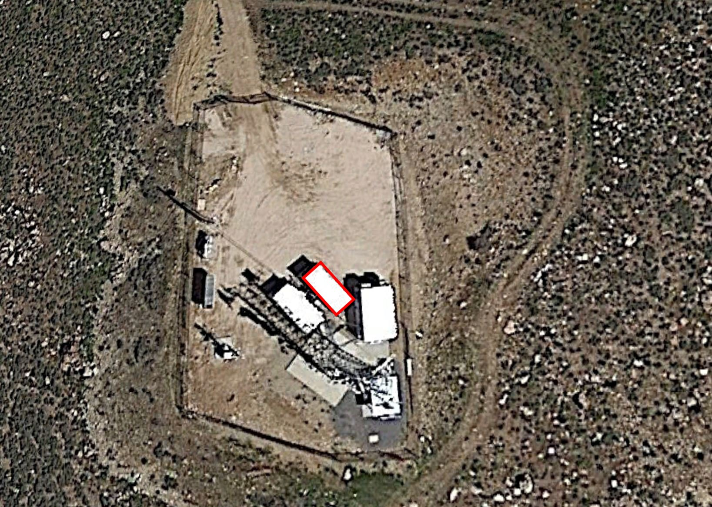

EXHIBIT B
DESCRIPTION OF LEASED SPACE and RESPONSIBILITIES

UCA is currently operating and maintaining a conventional 800 MHz radio at the Weber County Liberty site. The conventional radio is controlled by dispatch via microwave radio link from Mount Ogden. The conventional radio and microwave equipment is rack mounted in a “Conex” style shipping container. The microwave antenna and omni directional antennas are mounted to the Liberty tower.

UCA would like to upgrade the existing conventional radio system to a P25 trunked system by June of 2024. Upgrading the system will require the following tasks to be completed from UCA, its partners, contractors or subcontractors:

- Install one, 85.5” X 20.5” X 19.3” (H X W X D) radio equipment rack in conex box.
- Install one, 83” X 24” X 24” (H X W X D) radio equipment rack in conex box.
- Install one, Sinclair SC4099 series omni directional antenna near the top of the Weber County tower.
- Install one tower top amplifier at the base of the P25 antenna.
- Install associated coax cables to antenna and TTA.
- Install one floor mounted UPS, subpanel, and outlets.
- Install an external 25 KW emergency generator with automatic transfer switch.
- Install a 1000-gallon propane tank and fuel line.
- Install two additional RF entry ports in the shelter.
- Install / upgrade interior and exterior grounding to current P25 standards.
- Upgrade existing HVAC if required.
- Upgrade 4.9 GHz microwave circuit with licensed 11 GHz Ethernet connectivity.
- Remove 800 MHz omni antenna and conventional radio after UCA cuts over to P25 system.

UCA is responsible:
- UCA will provide, own, install and maintain the external generator, 1000-gallon propane tank and automatic transfer switch.
- UCA will provide emergency backup power to UCA equipment, and any Weber County owned and maintained equipment currently in the conex box.
- UCA will own and maintain UPS.
- UCA will fill the propane tank at UCA’s expense.
- UCA will own and maintain the HVAC system.
- UCA to provide Weber County with structural Analysis for tower that would include new P25 antenna and replacing microwave antenna.

Weber County is responsible for:
- Weber County to provide and maintain a right of way to the site that includes 24 x 7 x 365 access.
- Weber County to provide commercial power to shelter.
- Weber County to maintain tower ensuring that it is safe to climb by keeping an up to date passing structural analysis on file.
- Weber County to maintain site security via adequate fencing and gate(s).

